**Concept Selection**

1. **Introduction**

The purpose of concept selection is to evaluate each previously generated concept and determine which is the most viable to advance in the design process. The significance of concept selection is that it utilizes empirical measurements to select the best concept for the customer without interference from designer biases. This report presents a matrix-based down-selection of each concept using previously identified selection criteria. First introduced is the concept screening process, which assesses positive or negative concept criteria performance relative to a baseline concept. Once concept screening is completed, this report advances to the concept ranking, which assigns quantitative values to the positive/negative performance of the top concepts from the concept screening. Finally, the chosen concept is presented as the design the team plans to advance to fabrication. All referenced concepts are provided in the appendix and are referenced by their numbers throughout the report.

1. **Concept Screening**

The concept selection matrix’s main function is to narrow down the options by eliminating concepts that score too low in addressing customer requirements. The selection criteria was based on the customer requirements formulated in the Functional Decomposition and Concept Generation report. Each concept was rated relative to the reference, concept 1, to decide which concepts would be desirable to move forward with. The reference concept was decided unanimously among the group to be the best “middle path” due to its simplistic design and intuitive nature, but other concepts could outperform it due to issues inherent with a spinning weight on a moment arm. In the matrix, a "+” indicates that the given concept would outperform the reference in the customer requirement, while a “-” indicates it would underperform in relation to the reference. A “0” means that it would perform the same as the reference concept. It should be noted that when the table was first created, more selection criteria existed (as shown in the Needs Metrics Matrix in the appendix) but were removed due to similar performance across concepts. This would have given a result of “0” along the entire column, and therefore would not have had any factor in changing the comparative scores. The results of each concept performance are shown in Table 1.

*Table 1: Selection Matrix*

The final score for each concept was calculated by subtracting the sum of “-”s from the sum of “+”s. The concepts were then ranked based on these scores and the top three scoring concepts moved on to the second round of concept ranking. The ratings were given based on analysis and a vote of each group member comparing each concept with the reference. The top three concepts based on Table 1 are concepts 2, 4, and 5. Concept 2 is the design with solenoids inducing vibration, concept 4 is the hydraulic actuator-based design, and concept 5 is the linearly oscillating weight that is moved up and down with a crank. Concepts 1 and 3 did not have a high enough score to move on to the second round. Concept 1 underperformed in multiple areas, including contact to bridge and operating at different frequencies. Concept 3 underperformed in the categories of clear and safe operation instructions and resolution of at least one Hertz.

1. **Concept Ranking**

The top three out of five concepts proposed were used to create a concept ranking matrix to condense the list of possible candidates for a final concept. The concept ranking matrix would further derive which design was the best to move forward with. Each concept was given a rating between 1 and 5 based on how well it meets each selection criterion of the project. A rating of 5 indicates a significant improvement from the reference design while a 1 indicates a severe deficit. The importance weight factor was determined by the team in the product specifications report with the Needs Metrics Matrix. The importance weight factors were normalized across the selection criteria (see appendix for normalization formula) and multiplied with the rankings, resulting in a weighted score for each criterion. All the weighted scores for a concept were added together for a total score. The highest total score would be the concept deemed the best to move on with for the project. Table 2 shows the concept ranking matrix and concludes that concept 5, a linear weight with a DC motor, is the best option due to its vast improvement on the reference.

Table 2: Concept ranking with importance weight factors.

It was decided that the linear weight with a DC motor would test vibration and be easier and safer to use than the other concepts. The highest importance weight factors corresponded to the clear and safe operation instructions, robust, portable, and leave bridge undamaged selection criteria. Concept 5 ranked higher relative to the other concepts in three out of four of these categories, which explains its higher total score and designation as the best concept.

1. **Final Concept**

The concept selection tables designated the highest-scoring concept as the best design. Concept 5, the linear weight powered by a DC motor shown in Figure 1, scored highest in both tables because of its ability to test vibration data at a wide range of values, as well as the ability to transfer energy more efficiently to the bridge.

Figure 1: Excitation via DC Motor and powertrain for linear actuation.

The generator will provide enough power to the system while still maintaining an ease of portability. The MOSFET will control the flow of power from the generator to the DC motor and Arduino. Desired values for frequency and time can be input via the keypad, and the Arduino will control the speed to match the desired frequency. The energy of the DC motor will be translated through the gears and into the weight to create a linear motion, which will transfer downwards via the shaker’s weight into the bridge, inducing vibration. In an interview with stakeholder Joud Satme, he expressed concerns about concept 1’s ability to transfer energy from the shaker into the bridge and how rotational motion would be less efficient because forces were being exerted everywhere around the radius of the weight. Concept 5 can do this more efficiently by using gears to move a weight up and down to localize and create a one-dimensional force. This force would be better suited for testing vibration data because there is minimal wasted energy. This design is more complicated than some of the other concepts, but when evaluating the criteria for a productive shaker, concept 5 prevailed. The power train will add elements of difficulty in the design process, specifically trying to find an efficient gear ratio to excite all frequencies needed while not stalling the motor. To address this challenge, the team will source outside expert advice on gear train design, as well as create prototypes of gear ratios for experimental testing.

1. **Appendix**

Needs Metrics Matrix



Concept 1

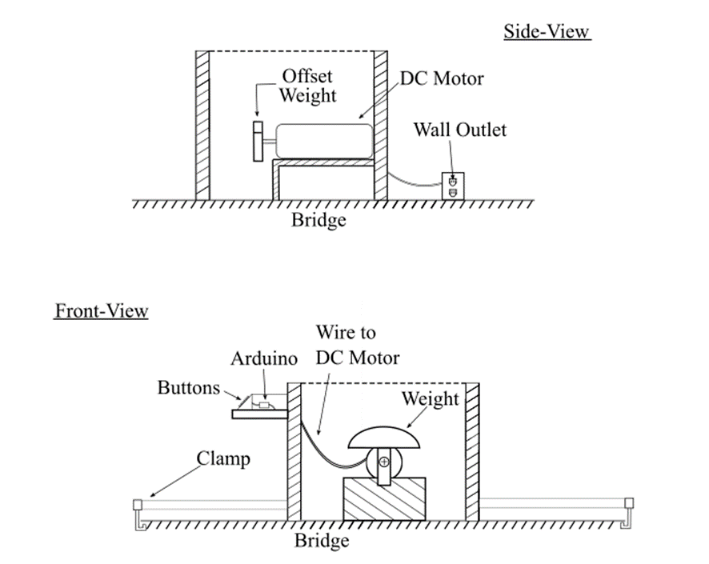

Concept 2

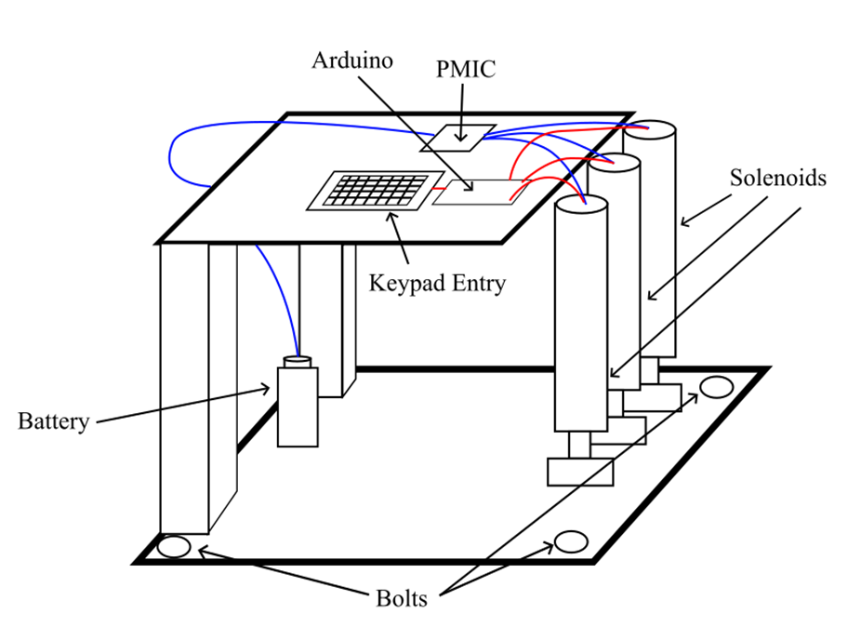

Concept 3

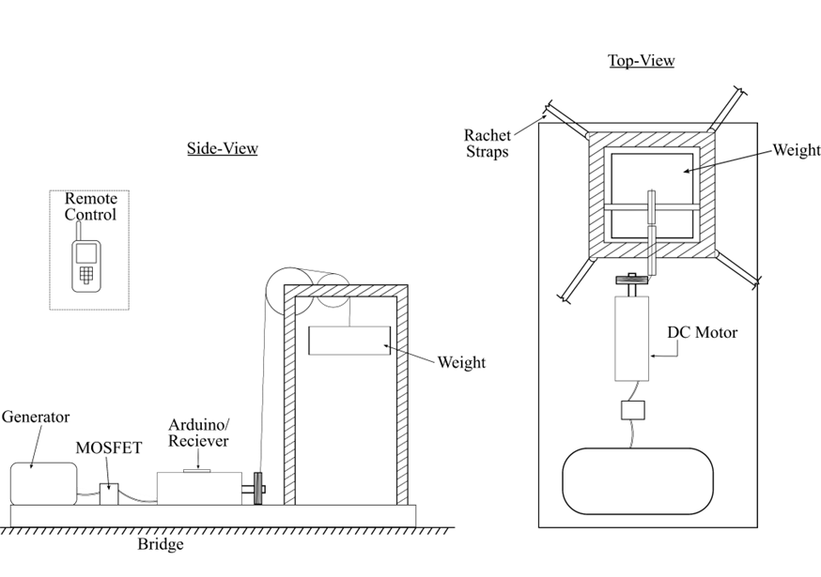

Concept 4

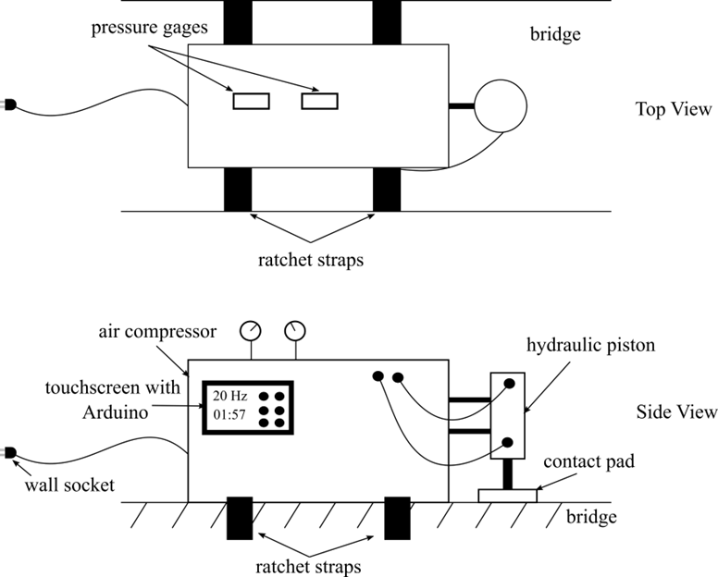

Concept 5

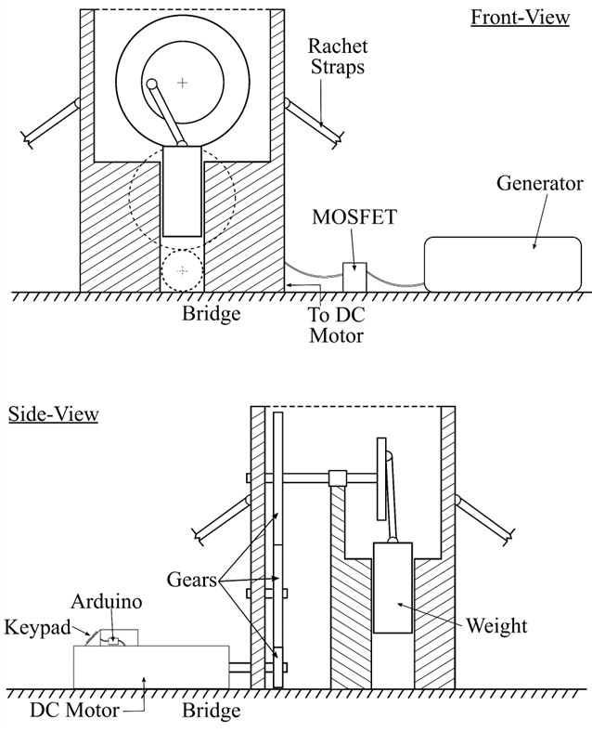

Normalization Formula

$$Importance Weight Factor= \frac{Individual product specification weight factor}{Sum of all product specification weight factors}$$